Minesweeper (Sprite and Tiled)

By: Scott & Max

**Project Overview:**

This project was based on trying to make Minesweeper in 2 different formats. One was with the tiled system while the other was just using sprites. The object was to get the user to click and would be shown either a mine or a space saying how many tiles around it were bombs.

**Disclaimer / List of known bugs:**

Both games are unfinished and are basically more of separate scratches then minesweeper. With problems arising due to github troubles and tiled acting up on the school computers. The sprite system did not work well either as a lack of understanding and general underwork meant little was accomplished except for creating a grid, switching between showing the grid and a gameover picture, and then being able to close the picture. Sprite version also crashes every single time it closes, most likely due to that amount of squares being drawn that it doesn’t want to close.

**User Manual**

**Sprite**:

<https://github.com/parks2214/Minesweeper_Scott.git>

Called Minesweeper_Scott it can be found under the code folder in the Max and Scott section. Not much to do for it. Apologize for the shifting colours but it is the best way to represent the different grid squares constantly being drawn. Click the bottom left corner grid square to find the mine and show the game over screen ( and to also exit the game).

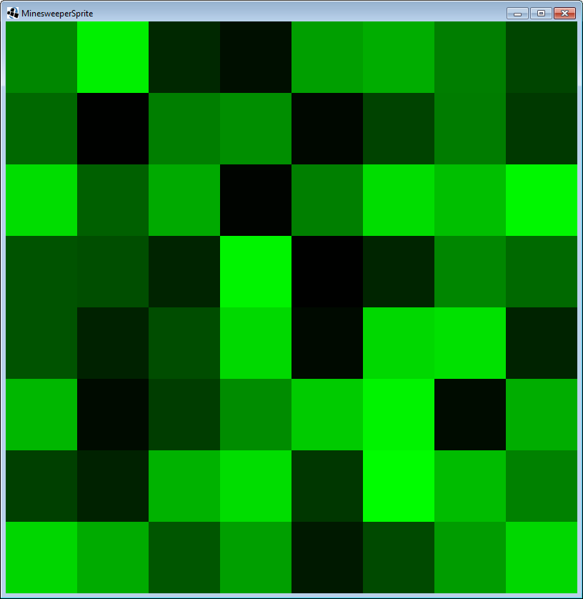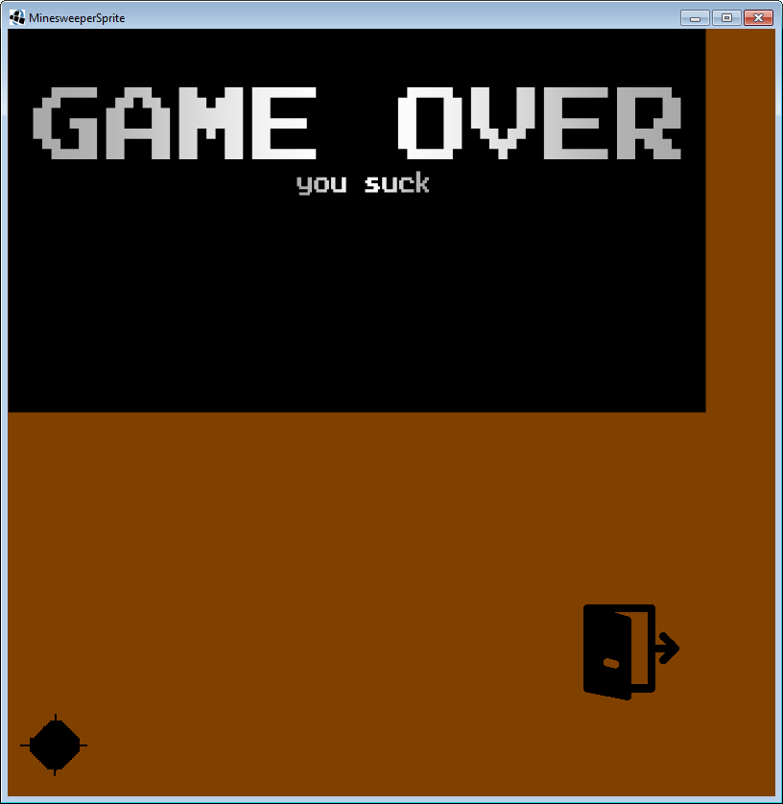

**Tiled:**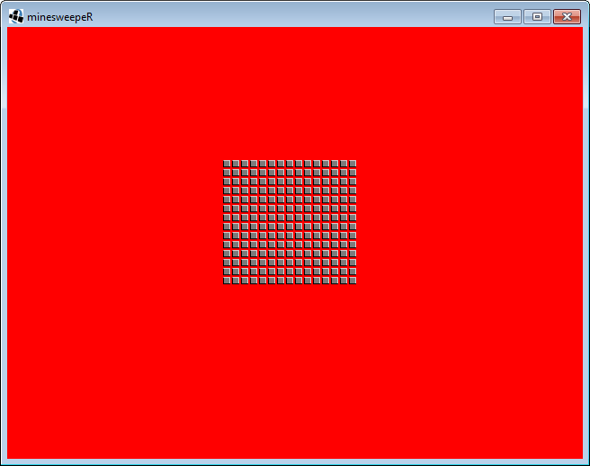

https://github.com/maxwellndi33/Tiled2  
 A 16x16 tiled map was loaded in to libgdx after many tries to get it to load in. The camera function messed up the view of the map so it rendered in at a different spot then we had wanted. Clicking against the map to reveal the other layers didn’t quite work to completion. The camera moved around the map based on arrow key pressed.

**Journals** (**Scott**):

**December 18th**: Was put with Max to work on Minesweeper. Since neither of us know which way of making minesweeper to go, He is going to use tiled and I’m going to try figuring it out with Sprites.

**January 12th**: I have no idea what I should be doing with sprites. I have been told on multiple occasions by Eric and Grondin that I need to use 2D arrays with grid coordinates to both make the squares and to show whether or not they are hidden, flagged, or seen. I think it has come down to me not asking the right questions and not getting it explained so that I would understand it.

**January 18th**: Frustrated with my inability to understand what it is I should be doing and how to do it. The amount of progress for me is nearly 0 daily and Max still struggles to get Tiled to work on the computers at the school. I’m ready for this semester to be over and to come back next semester with Devin and have larger breakthroughs.

**Sources:**

Minesweeper in processing made by Eric:

<https://github.com/EricSchilha/Minesweeper/blob/master/Minesweeper.pde>

Grondin’s Libgdx note / site in general:

<http://3ui.sgrondin.ca/ss24/index.html>

Libgdx Tutorial videos (extremely useful):

<http://www.gamefromscratch.com/page/LibGDX-Video-Tutorial-Series.aspx>

Tiled Map Tutorial:

<https://github.com/libgdx/libgdx/wiki/Tile-maps>

Another Tiled Tutorial, helped with loading problems:

<http://www.gamefromscratch.com/post/2014/04/16/LibGDX-Tutorial-11-Tiled-Maps-Part-1-Simple-Orthogonal-Maps.aspx>

**Notes to Future programmers:**

Don’t try and copy a game like minesweeper. Make something simpler and easier. That way you can mess around more with github and screen changes and more finite things. Being ambitious while great won’t help in trying to make a complex game.

**Lesson not taught:**

Favourite lesson not taught with notes or grondin was definitely Tiled. With no knowledge of tiled, I tried to make a minesweeper grid to be used in our game with click detection to reveal the bombs or numbers selected. Within the time of learning tiled, I was able to make and load the map in LibGDX. I figured out layers and objects and the scaling and how the camera works with regards to the map. It proved to be difficult but there was something to show for it in the end.